Sprint Report  
Sprint 6 Submission

Submission Date: 23 March 2021

Team A

Gregorson Mahon T00057640

Taylor Peck T00483746

Nicholas Piluso T00586492

Contents

List of tasks for the previous week 3

List of tasks for the coming week 4

Application Server Backlog: 4

Web Site Backlog: 4

Project Management Tool Screenshot 5

Updated Mock-ups or Other Relevant Documents 6

# List of tasks for the previous week

|  |  |
| --- | --- |
| Task Name | Responsible Team Member |
| **Team Meeting for …**   * Team updates & discussion on what needs to happen next | All Team Members |
| **Continue development on web site:**   * Add functionality to edit properties and recipients to database * Created mainpage tables for recipients and properties w/ related functionality | Taylor |
| **Continue development on web site:**   * Resolved multiple TODO items – functions for checking password and account lock * Update database to store property longitude & latitude information | Gregorson |
| **Continue development of the Application Server:**   * Perform all unit, component and release testing for App Server. * Deploy App Server. | Nick |

# List of tasks for the coming week

|  |  |
| --- | --- |
| Task Name | Responsible Team Member |
| **Team Meeting for:**   * Development wrap-up and preparation for project presentation | All Team Members |
| **Continue development on web site:**   * SMS script * Add SMS provider selection to DB and mainpage recipients * Testing and bugfixes | Taylor |
| **Continue development on web site:**   * TODO items as required * Testing and bugfixes | Gregorson |
| **Application Server:**   * Resolve any lingering errors that pop up. * Add SMS (via email) functionality   **Continue development on web site:**   * Assist with testing and bugfixes | Nick |

# Application Server Backlog:

* SMS (via email) functionality ***(Assigned to Nick March 22, 2021)***

# Web Site Backlog:

* Functionality to handle if a user’s account is locked (redirect to a new page informing the user with an option to go back to startpage?). ***(Assigned to Gregorson March 22, 2021)***
* Add carrier selection to Recipients database and selector in mainpage forms and tables, update associated methods. ***(Assigned to Taylor March 22, 2021)***
* Bug: Duplicate property names (even on different accounts) do not work.
* Bug: Empty phone number in add and edit recipient forms passes “” to database insert method, causing it to fail.
* Test
* Reconfigure UI of pages to improve UX.

# Project Management Tool Screenshot

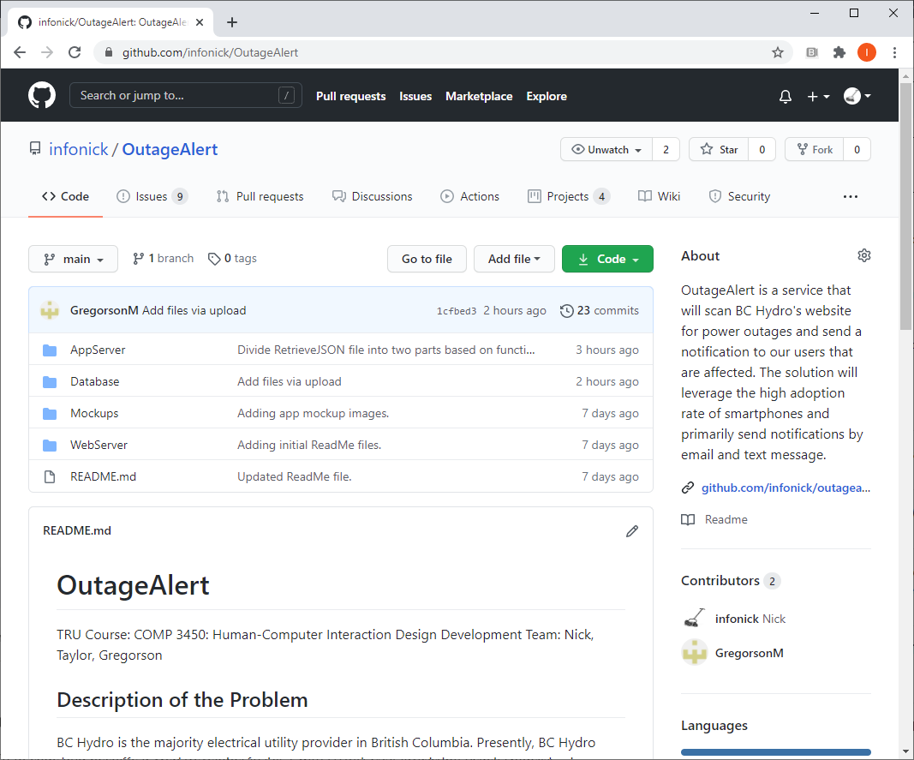

Interested readers may review the GitHub: <https://github.com/infonick/OutageAlert/>

# Updated Mock-ups or Other Relevant Documents

“You can include any other information such as screenshots of your app in progress or mock-ups showing what you plan to do in the coming week.”

